

Use Case Specification: eCL Manager Review
For
eCoaching Log

Change History Log

Date | Version | Description | Author
01/12/2015 | 1.0 | Initial Document | Doug Stearns

Table of Contents

1. Brief Description 5
2. Participating Actors 5
2.1 Primary 5
2.2 Secondary 5
3. Basic Flow of Events 6
3.1 Access eCoaching Log website My Dashboard page. 6
3.2 Select eCoaching Log from My Pending eCoaching Logs section with a Pending Manager Review status (manager of CSR). 6
3.3 Read and review information on the review page. 6
3.4 Confirm if coaching opportunity log is a Customer Service Escalation (required entry). Select Yes to confirm CSE. 6
3.5 Enter or select the date coached (required selection). 6
3.6 Enter details from the coaching session including action plans developed (required entry; free form text up to 3000 characters). 6
3.7 Submit the review for eCoaching Log to be reviewed by Supervisor. 6
4. Alternative Flows 7
4.1 Select Pending Manager Review not CSE coaching log. [Step 3.2] 7
4.2 Select Pending Manager Review coachable OMR coaching log. [Step 3.2] 7
4.3 Select Pending Manager Review not coachable OMR coaching log. [Step 4.2.4] 7
4.4 Select Pending Sr. Manager Review is CSE coaching log. [Step 3.2] 7
4.5 Select Pending Sr. Manager Review not CSE coaching log. [Step 4.4.3] 8
4.6 Select Completed coaching log. [Step 3.2] 8
5. Preconditions 8
5.1 eCoaching Log website available. 8
5.2 eCoaching Log database available. 8
5.3 eCoaching Log database populated with correct and current hierarchy information for Employee, Supervisor, Manager. 8
5.4 eCoaching Log Submissions and Notifications have taken place. 8
5.5 eCoaching Log Dashboard is available. 8
6. Postconditions 9
6.1 Appropriate review information is written to database. 9
7. Assumptions and Dependencies 9
7.1 Access to Supervisor Dashboard will be limited to those with the following job codes. 9
8. Business Rules 9
8.1 none 9
9. Technical Requirements 9
9.1 none 9
10. Activity Diagrams 10

Table of Figures
Figure 1 – eCL Manager Review 11

Brief Description
eCoaching Logs Manager Review for those who are managers of coaching log recipients. Managers review escalated logs, determine if coaching is needed, develop action plans, and work with Supervisors to provide coaching to employees. Note: managers can be managers of CSRs or supervisors.

Participating Actors

Primary

Managers (review escalated eCoaching Logs and determine coaching for Employees)

Secondary

None

Basic Flow of Events

Access eCoaching Log website My Dashboard page.

Select eCoaching Log from My Pending eCoaching Logs section with a Pending Manager Review status (manager of CSR).

Read and review information on the review page.

Confirm if coaching opportunity log is a Customer Service Escalation (required entry). Select Yes to confirm CSE.

Possible options are:
Yes, this is a confirmed Customer Service Escalation
No, this is not a confirmed Customer Service Escalation

Enter or select the date coached (required selection).

Enter details from the coaching session including action plans developed (required entry; free form text up to 3000 characters).

Submit the review for eCoaching Log to be reviewed by Supervisor.

Alternative Flows

Select Pending Manager Review not CSE coaching log. [Step 3.2]

Confirm if coaching opportunity log is a Customer Service Escalation (required entry). Select No to confirm not CSE.

Enter or select the date reviewed (required entry).

Enter explanation for Employee and Supervisor as to reason why this is not a CSE (required entry; free form text up to 3000 characters).

Continue with Step 3.7 above.

Select Pending Manager Review coachable OMR coaching log. [Step 3.2]

Select eCoaching Log from My Pending eCoaching Logs section with a Pending Manger Review (manager of CSR).

Read and review information on the review page including Outlier Management Report Research SOP.

Enter or select the date (required entry).

Confirm if research indicates the log does require coaching. Select Yes does require coaching.

Possible options are:
Yes
No

Enter reason, explanation, or justification why item is coachable for Supervisor (required entry; free form text up to 3000 characters).

Continue with Step 3.7 above.

Select Pending Manager Review not coachable OMR coaching log. [Step 4.2.4]

Confirm if research indicates the log does require coaching (required entry). Select No does not require coaching.

Select main reason item is not coachable.

Possible options are:
Other

Enter reason, explanation, or justification why item is not coachable (required entry; free form text up to 3000 characters).

Continue with Step 3.7 above.

Select Pending Sr. Manager Review is CSE coaching log. [Step 3.2]

Select eCoaching Log from My Pending eCoaching Logs section with Pending Sr. Manager Review status (manager of a supervisor).

Read and review information on the review page.

Confirm if coaching opportunity log is a Customer Service Escalation (required entry). Select Yes to confirm CSE.

Possible options are:
Yes, this is a confirmed Customer Service Escalation
No, this is not a confirmed Customer Service Escalation

Enter or select the date coached (required entry).

Enter reason / explanation / justification why is a CSE (free form text up to 3000 characters) (required entry).

Continue with Step 3.7 above.

Select Pending Sr. Manager Review not CSE coaching log. [Step 4.4.3]

Confirm if coaching opportunity log is a Customer Service Escalation (required entry). Select No to confirm not CSE.

Possible options are:
Yes, this is a confirmed Customer Service Escalation
No, this is not a confirmed Customer Service Escalation

Enter or select the date reviewed (required entry).

Enter reason / explanation / justification why not a CSE (free form text up to 3000 characters) (required entry).

Continue with Step 3.7 above.

Select Completed coaching log. [Step 3.2]

Select eCoaching Log with Complete status

Read and review information on the review page.

Close review page.

Preconditions

eCoaching Log website available.

eCoaching Log database available.

eCoaching Log database populated with correct and current hierarchy information for Employee, Supervisor, Manager.

eCoaching Log Submissions and Notifications have taken place.

eCoaching Log Dashboard is available.

Postconditions

Appropriate review information is written to database.

Assumptions and Dependencies

Access to Supervisor Dashboard will be limited to those with the following job codes.
Module | Role | Job Codes
CSR | Manager | WACS40
Supervisor | Senior Manager | WACS60
Quality | Quality Lead | No escalated review necessary
LSA | LSA | No escalated review necessary

Business Rules

none

Technical Requirements

none

Activity Diagrams
Below is the activity diagram for the use case that provides a visual depiction of the flow of events.

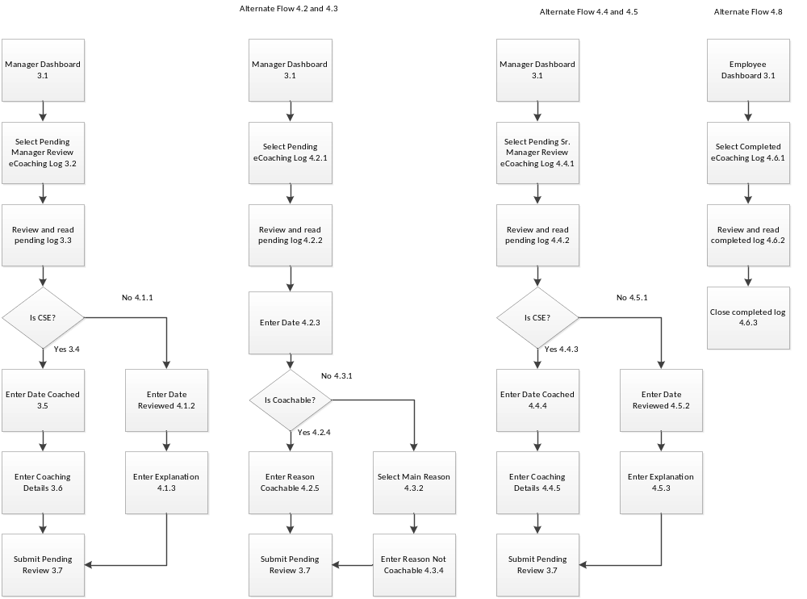

Figure 1 – eCL Manager Review

